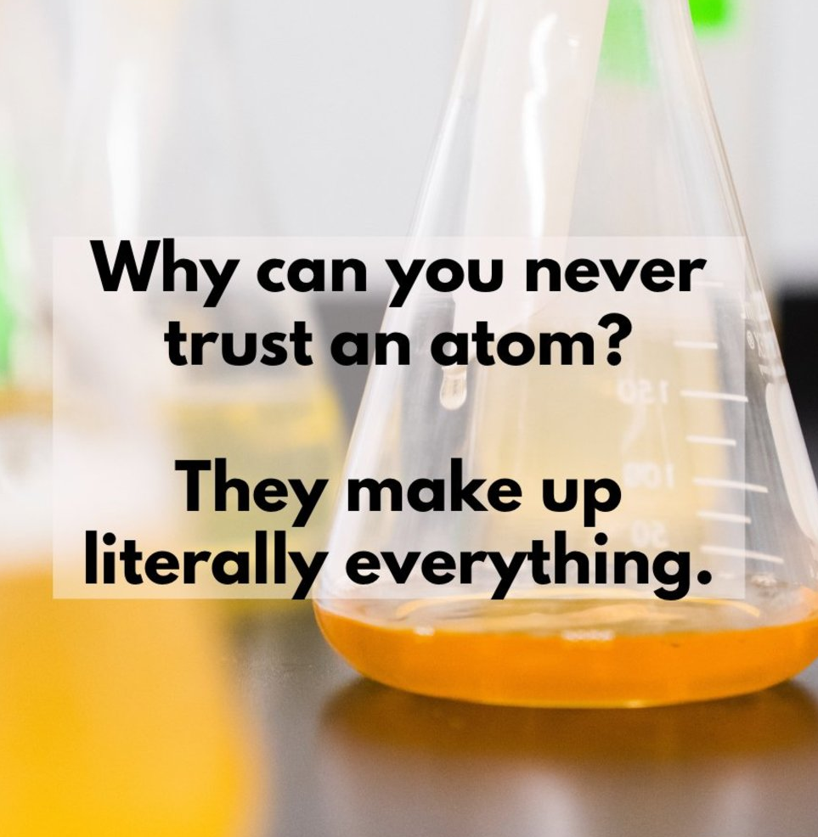
toDate : _________________________________
Chemical Foundations - Matter
Today we will be going over some grade 10 foundations skills we would expect you coming out of grade 10 with. In the next couple of weeks we will be spending more time on some of these concepts. Your strengths will help us decide how much time we spend on the topics. I am always available at lunch for extra support if you feel you need it.
The Periodic Table :

Subatomic Particles :

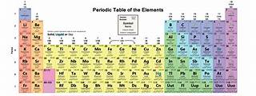

Bohr- Rutherford and Lewis Dot
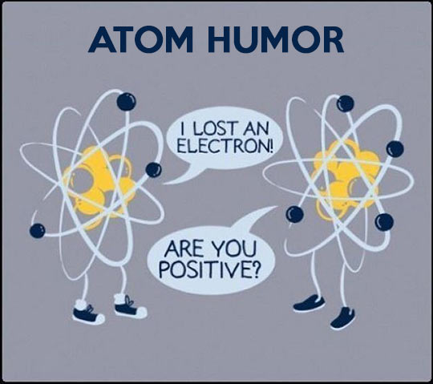

Atoms will form ions……but why?
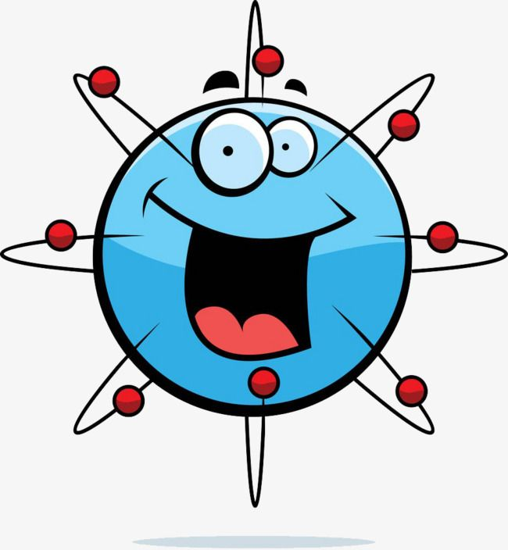

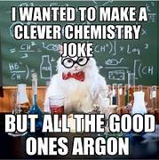
Bonding Types
What about those polyatomics and transition metals

Reaction types, and balanced chemical equations seemed like a big deal!

I bet you can’t get enough of this……..but wait until unit II!
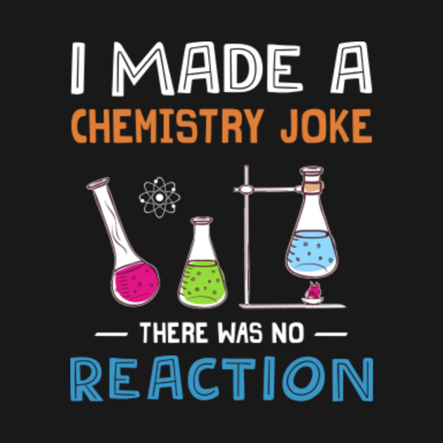

Some other stuff that might come up during discussion or practice work
