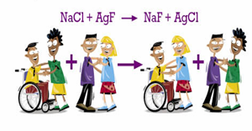
Date : ___________________________
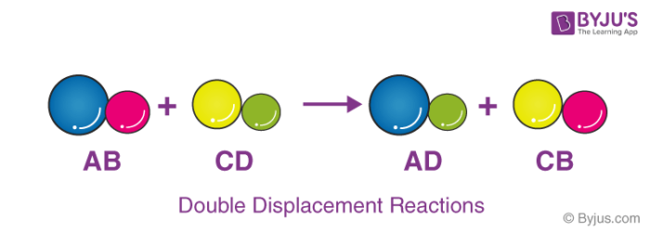
Double Displacement Reactions – Day I
In double displacement reactions:

The products of a double displacement reaction vary, we classify the reactions based on their products
-
-
-
I ) Precipitation Reactions

- In a precipitation reaction a _____________ is produced when two solutions are mixed. This means that one of the products is not soluble in water.

- We will further examine solutions and solubility in chapter 4, but for this unit it will be important that you can predict if a compound will precipitate in solution.

- The solubility table ( on the back of your periodic table ) will be used to determine precipitates.
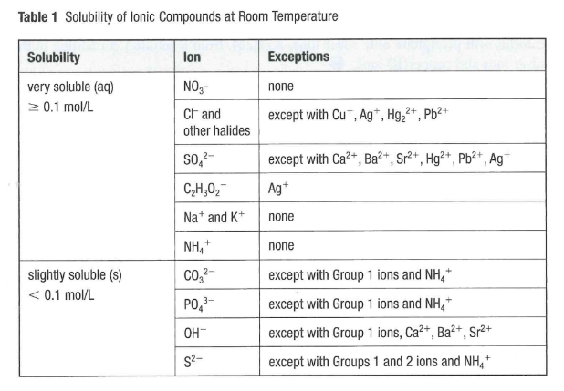
Using the Solubility Table to Determine Precipitates
Steps:
- Determine the anion and find it on the table
- Check if it is in the “Soluble or “ Not Soluble” category
- Check to see if the cation is in the exception list
- State if the compound is soluble ( aq ) or not soluble ( s ) in solution.
This table is on the back of your periodic table
Compound | State in Solution
Silver Nitrate
Magnesium Sulfate
Calcium Sulfate
Calcium Carbonate
Potassium Phosphate
Silver Chloride
Lithium Hydroxide
Aluminum Sulfide
Ex. 1 – Will a precipitate form when solutions of potassium chloride and silver nitrate are combined. If you predict a precipitate will form, balance the equation for the reaction.

Ex. 2 – Will a precipitate form when solutions of potassium sulfate and iron ( III ) chloride are combined. If you predict a precipitate will form, balance the chemical equation for the reaction.

You Try : Predict a precipitate and balance the equation if needed for the following combination of solutions;
- Silver Nitrate and Potassium Phosphate


- Calcium Bromide and Potassium Hydroxide

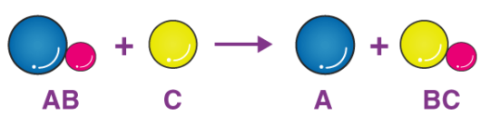
Date : ______________________________________

Double Displacement Reactions – Day II
II ) Reactions That Produce Gases
Many double displacement reactions that involve ____________ can produce gasses. These gasses can be produced directly or indirectly
Direct Gas Production
Involves :
Potassium Sulfide and Hydrochloric Acid

Indirect Gas Production
Involves :
Ex.1
Ex 2
III ) Neutralization Reactions :
The reaction of an _____________ and a ________________ to form more neutral products
Neutralization reactions do not normally produce precipitates so how would you be able to determine if a reaction has occurred?

Ex. 1 Magnesium hydroxide and hydrochloric acid

Ex. 2 Sodium hydroxide and sulfuric acid

