
Date : _____________________________
Why Polarity Matters – Intermolecular Forces
We have seen that ionic solids are held together by strong electrostatic forces within their crystal lattice, and that covalent bonds hold molecular bonds together, but what holds one molecule to the next?
Intermolecular Forces –

- Dipole-Dipole Attraction :

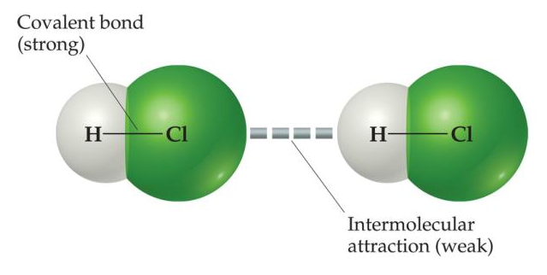

- Hydrogen Bonds :
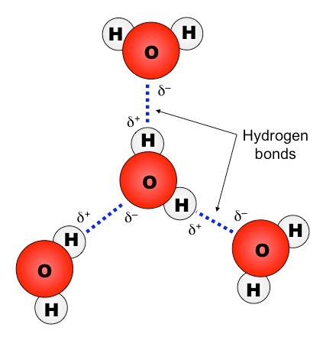
- London Dispersion ( Van Der Wall’s ) Forces

The Polarity of a molecule and the intermolecular forces that are created determine how the molecules will interact with one another, and the determine the ________________________ of the compounds.

Ex. 1 – Which would have a greater boiling point Cl₂, HBr, H₂O

Ex. 2 – Why is propane ( C₃H₈ ) a gas at room temperature and Octane ( C₈H₁₈) a liquid?

Ex. 3 - Rank the freezing point from highest to lowest for the following ; CH₄, CCl₄ CH₃Cl

