
Date : _______________________________
Introduction To Reactions
Evidence of a Chemical Change
All chemical reactions result in the formation of new substances. How can you tell that a new substance has been produced?

-
-
-
-
Note – Any or all of these clues may occur

Describing Chemical Equations :

Word equations : Hydrogen peroxide decomposes to produce water and oxygen

Skeletal equation :

Balanced Chemical Equation :

We need to balance chemical equations to follow the Law of Conservation of Mass
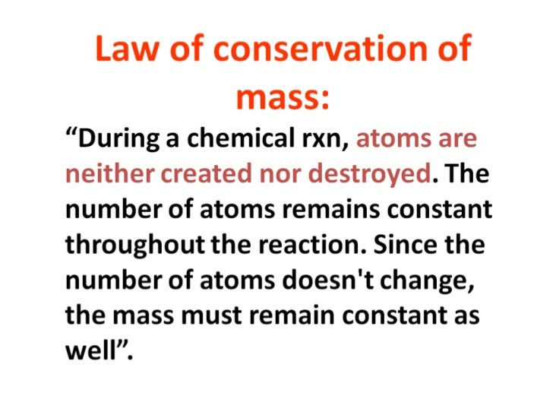

Balancing Chemical Equations :
In order to fulfill the law of conservation of mass it is critical that the number of atoms of each type of element is the same on both sides of the equation ( reactants and products )

Ex. 1 Na + O₂ Na₂O

Ex. 2 Cu + AgNO₃ Cu(NO₃)₂ + Ag

Ex. 3 Fe(NO₃)₃ + (NH₄)₂CO₃ Fe₂(CO₃)₃ + NH₄NO₃

Note – Being able to balance chemical equations quickly and accurately is another essential skill required for this course……Practice a lot!

