Date : __________________________________
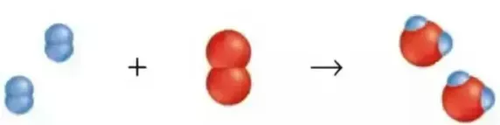
The Mole Ratio in Chemical Reactions
The formation of water involves the synthesis of hydrogen and oxygen
Write the balanced chemical equation for this reaction in the table below
H₂ | O₂ | H₂O
2 molecules | 1 molecule | 2 molecule
4 molecules | 2 molecules | 4 molecules
 | 4 molecules
2 moles | 1 mole | 2 mole
 |  | 8 mole
 | 3 mole

Mole Ratio The ratio of the amount ( in moles ) of one chemical to another in a chemical equation. The describes the ratio of the amount of reactants required to react and the amount of products they will yield. The mole ratio is related to the coefficients in the balanced chemical equation.

Ex. 1 – What amount of hydrogen is produced when 5.2 mole of ammonia decomposes?

Step 1 – Write the balanced chemical equation

Step 2 – Use the mole ratio from the BCE and
set up an equivalent ratio with the
values stated in the question.

Step 3 – Solve for the unknown

Ex. 2 – Aluminum quickly reacts with oxygen to produce aluminum oxide. What amount of oxygen is required to react with 6.4x10⁻² mol of aluminum?

