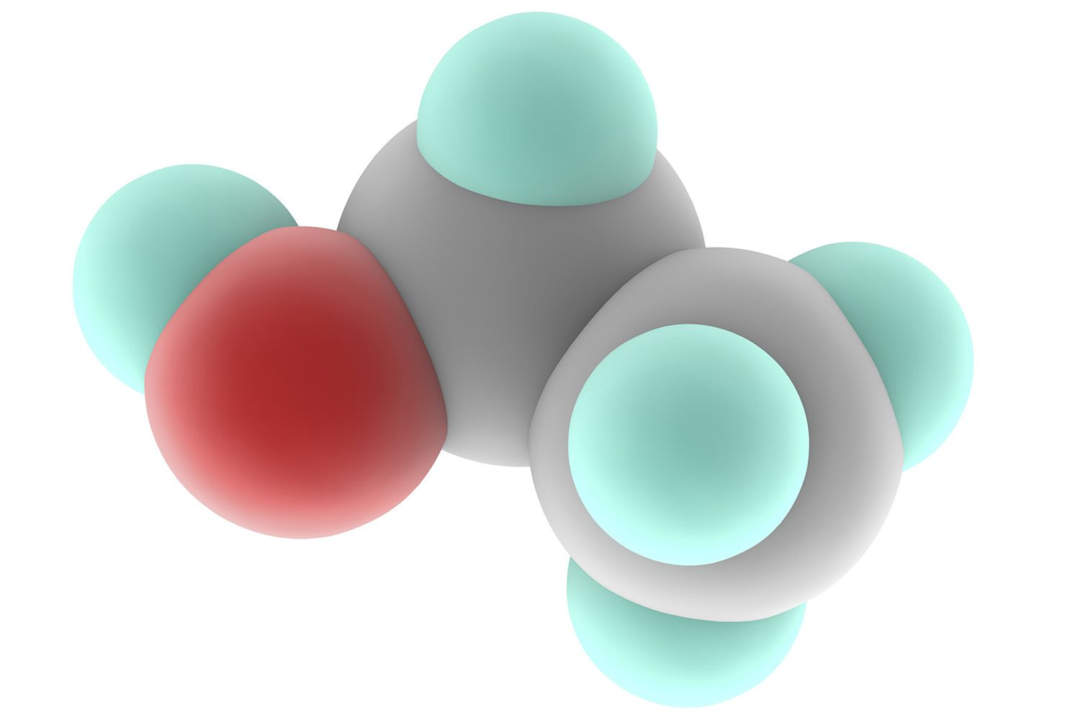
Date: ______________________________

Molecular Compounds
Properties of Molecular Compounds
- Mixes of solids/liquids and gases at room temperature
- Often softer
- Relatively lower boiling points
- May not readily dissolve in water
What do these properties tell us about the bonds and structure of molecular compounds compared to ionic?
You learned in grade ten that the 2 electrons in the bond of a molecular compound are ________________________, this is called a _______________________________bond
The elements will share pairs of electrons to complete the _____________rule.
The Formation of Molecular Compounds
Other than the diatomic molecules the sharing of electrons is actually a bit of a tug of war with no winner!
What might cause this tug of war?

Molecular Elements
– Compounds formed by the combination of the same types of elements a fancy name for the __________________compounds
- You need to memorize that the 7 diatomic elements are ;
Ex’s.
Hydrogen Oxygen Nitrogen

Molecular Compounds
Ex’s.
Hydrogen and Chlorine Hydrogen and Oxygen Carbon and Oxygen

In order to simplify diagrams, chemist will often only include the covalent bonds in their diagrams, the remaining lone pairs of electrons may or may not be included.
Draw the Lewis Structure for each of the following molecules

F₂ PH₃ SiCl₄

C₂H₆ C₂H₄

