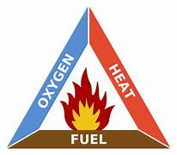
Date : ______________________________
Combustion Reactions
Combustion is

Hydrocarbon Combustion:
In this course we will focus on the combustion of hydrocarbons. Hydrocarbons are compounds that contain only _________________________________.
All hydrocarbons burn provided they are hot enough and have sufficient oxygen. Hydrocarbon combustion can be further classified into __________________________ and _____________________________ combustion.
Complete Combustion of Hydrocarbons:
Occurs when______________________________________________________.
General Equation : C_{x}H_{y} + O₂ CO₂ + H₂0
Specific Example : Methane ( CH₄)
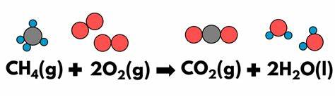

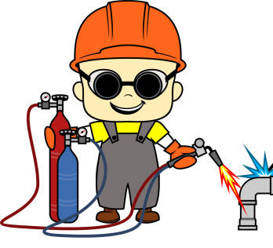
Ex. 2 – Ethyne ( C₂H₂ ) commonly known as acetylene, burns at 35000C. Write the balanced chemical equation for this reaction.

Incomplete Combustion of Hydrocarbons
Occurs when ______________________________________________
Evidence of incomplete combustion :
Depending on the amount of oxygen a variety of combustion products can be produced, for example the combustion of Heptane ( C₇H₁₆ ) when oxygen is limiting
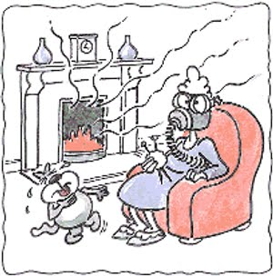
C₇H₁₆ + 7O₂ 3C + 2CO + CO₂ + 8H₂O

Practice : Write and balance the complete combustion reaction of Heptane below

