
Date : _______________________________

Electronegativity and Bonding

In the atomic tug of war game with electrons, are all atoms equally as strong? Why or why not?

Electronegativity :

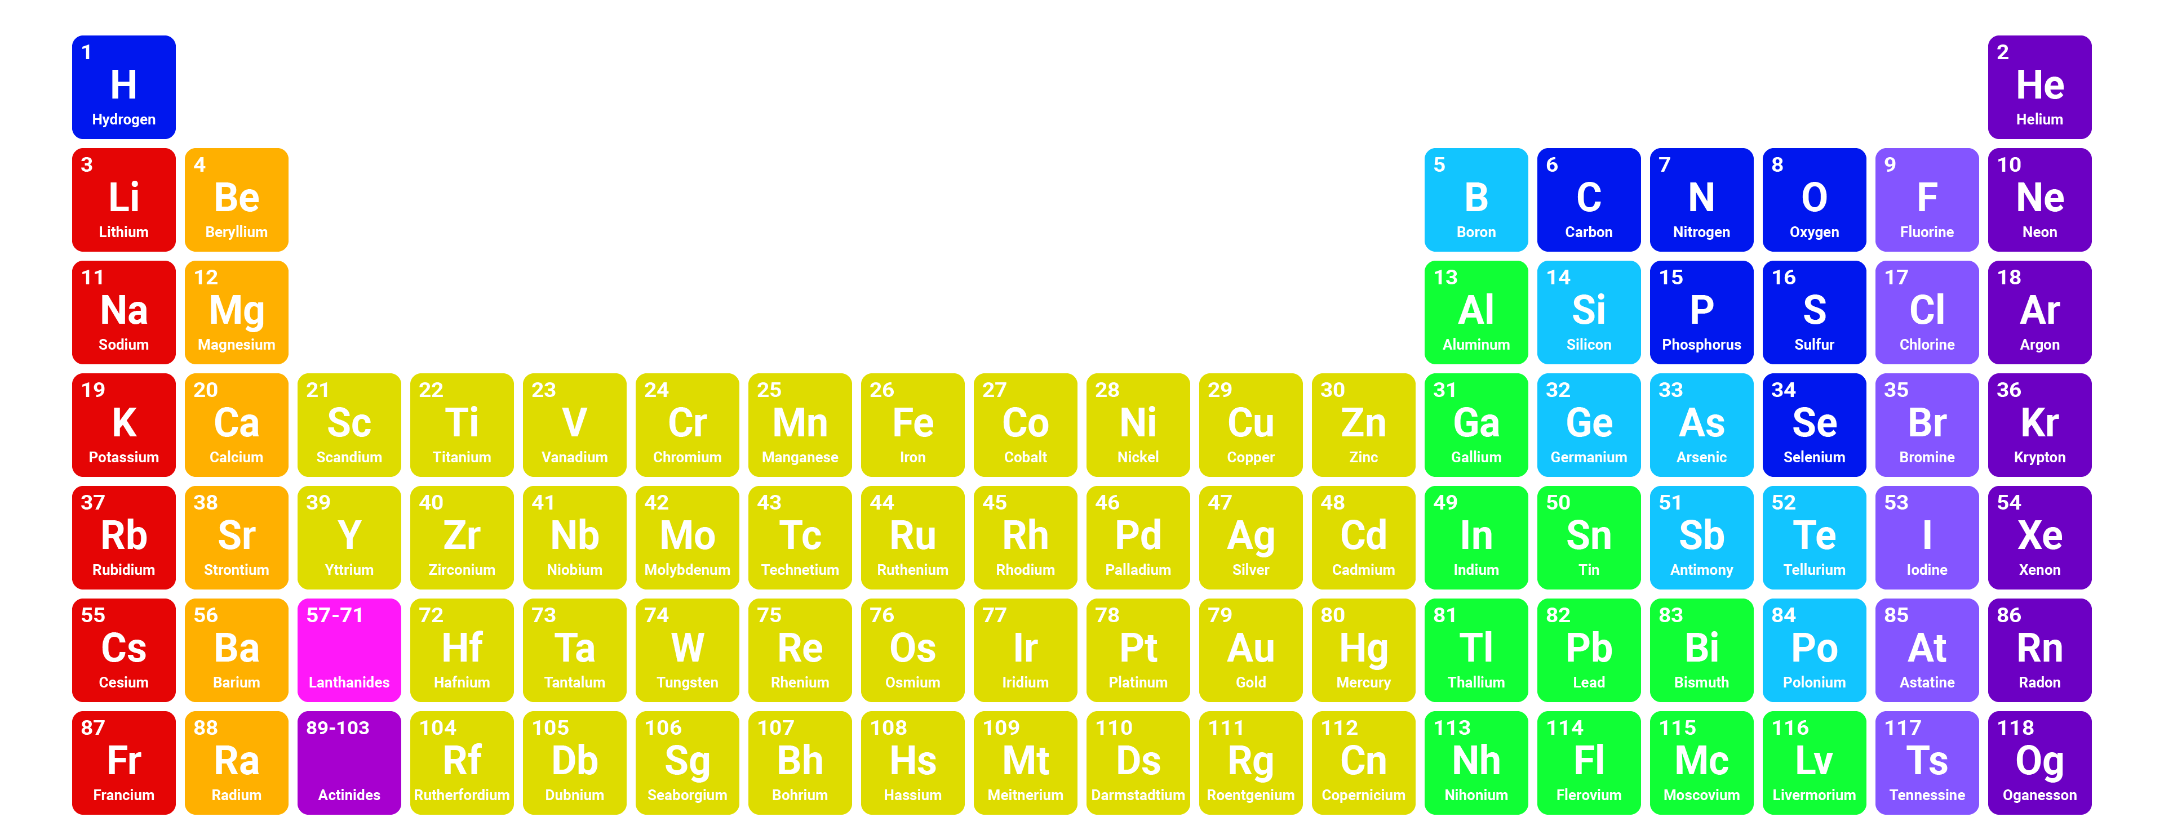
General Periodic Trends :

Ionic vs Molcular :
Your current understanding of what determine molecular and ionic compounds is a good general rule, but we can use electronegativity to quantitatively determine if electrons will be shared or exchanged.
To do this we calculate the difference in the elements electronegativity, this is called the Electronegativity Difference and is given the symbol _______.
Ex. Sodium and Chlorine

Please complete the table below to show the electronegativity difference between the selected bonds
Bond | ΔEN
H - H
C - H
N - H
O - H
Mg - Cl
Na - Cl
Ca - F

The story goes a little deeper……..Types of Covalent Bonds
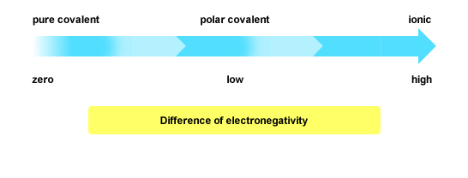

 | Non-Polar ( Pure ) Covalent | Polar Covalent
*ΔEN Range
Example | - All Diatomic Molecules
*Please Note – These values will change depending you date source and teacher. For this course please use these values in you determination.

