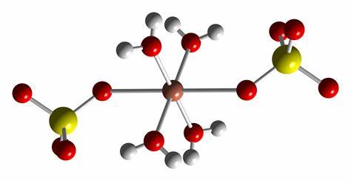
1Date : ____________________________
Hydrates
Hydrates are a group of ionic compounds that contain water molecules within there crystalline structure.
For example – Magnesium sulfate heptahydrate -
Determine the molar mass of Magnesium hydrate heptahydrate

Determine the molar mass of Barium hydroxide octahydrate

Some hydrates can be heated forcing the water molecules to leave the compound. As the water leaves the compounds physical and chemical properties change.
Would this be an example of a physical or chemical change?

The balanced chemical formula when water is driven from magnesium sulfate heptahydrate would be:

What type of reaction do you think this would be?

Write the balanced chemical formula for the decomposition of sodium carbonate decahydrate

These reactions are reversable. We will examine this after the lab today!

Copper Sulfate Pentahydrate Investigation
Safety : - Copper sulfate pentahydrate is an irritant, gloves and goggles are required
- We will be using Bunsen burners, tie back long hair and secure loose clothing

Procedure :

- Use a scale and obtain approximately 3.00 grams of copper sulfate pentahydrate. Record the exact amount you used on the supplied table. Place the hydrate into a heat resistant test tube
- Using a test tube clamp gently heat the hydrate over a flame move the sample continuously. Safety – make sure the mouth of test tube is never pointed at another classmate!
- Continue to heat until all signs of condensation stop. Be careful not to overheat the hydrate, if you do it will form a black ash, which is not the product you are looking for!
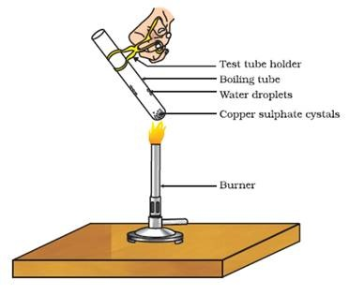
- Record the final mass of the products of the reaction

 | Reactant |  | Products
Word | Copper Sulfate Pentahydrate |  |  | +
Chemical Formula |  |  |  | +
Balanced Equation |  |  |  | +
Mass Before |  |  |  | +
Mass After |  |  |  | +
Molar mass Reactants and products |  |  |  | +
Moles of reactants and products |  |  |  | +

