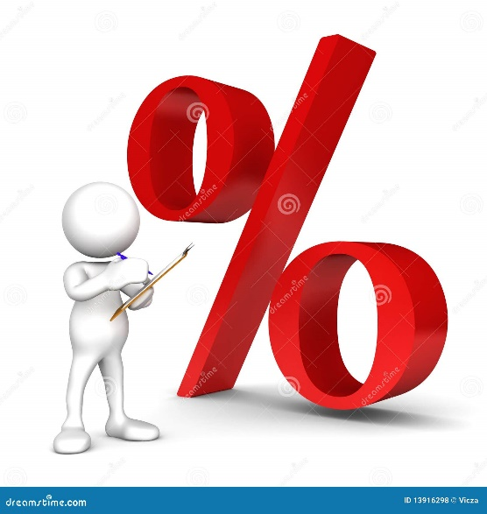
Date : _____________________________
Percentage Yield
In an ideal chemical reaction, all of the limiting product is converted into the desired product.
Theoretical Yield –

However, life is rarely ideal!
Actual Yield –

Factors that limit yield :
Nature of the reaction –

Experimental Design Errors –

Impurities –

Competing side reactions –

Calculating Percent Yield –

Ex. – Methanol, CH₂OH, can be made in a synthesis reaction using carbon dioxide and hydrogen, water is also produced in this reaction. During an investigation, 20.00g of hydrogen was reacted with excess carbon dioxide to produce 102.00g of methanol. What is the percentage yield of this reaction?

