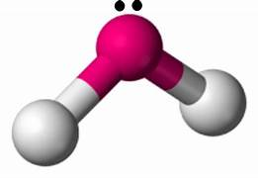
Date : __________________________________
Why Shape Matters to Matter – Compound Polarity
Recall : Electronegativity – The ability of an atom to attract an electron to itself while bonding. In general, as you move left to right across a period on the table electronegativity ___________________________. ( can you explain why?....the exam is near!!!)
Within a single bond we can determine the electronegativity difference between the atoms involved and determine if the bond is
- ______________________________ - Has an electronegativity difference of less than 0.4
Ex.
- ______________________________- Has an electronegativity difference of less than 1.7 but greater than 0.4
Ex.
- ______________________________- Has an electronegativity difference of greater than 1.7

Ex.

While it can be important to know if an individual bond is polar or not, it of often more important to decide if an entire molecule is polar or not. To determine this we need to consider a molecules shape as well as electronegativity differences within it’s bonds.
This year we will be looking at four molecular shapes ( there are more that will come up in grade 12 )
Please use the model kits to construct the following molecules ( Black = Carbon, White = Hydrogen, Red = Oxygen ). Recall your knowledge of Lewis Structures from unit 1 and draw the molecule
Molecule | Visual | Shape | Another Example | Polar or Non-Polar
Hydrogen Gas
Hydrogen Chloride
Carbon dioxide
Methane
( carbon tetrahydride )
Water
Ammonia
( nitrogen trihydride )

More Examples:
Molecule | Shape | Rational and Polarity determination
Carbon tetrafluoride  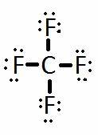 |  | The pull on the electrons is of _______________________________ and in  ______________________________ directions therefore the molecule is ______________________________.
Phosphorus trichloride  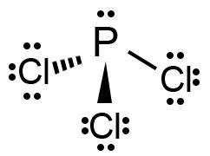 |  | The pull on the electrons is of __________________________________, but ______________ in opposite direction, therefore the molecule is ________________________________________.
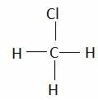  Chloromethane |  | The pull on the electrons is _____________ of equal magnitude in opposite directions therefore the molecule is ______________________________
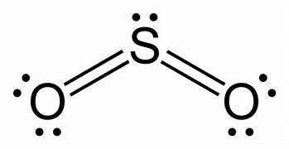  Sulfur dioxide |  | The pull in the electrons is of _________________________________, but ___________________not in opposite directions, therefore the molecule is _______________________.

More for you to try. For each molecule look up a picture and draw the structure. Determine the shape and decide on polarity with a rational
Molecule | Shape | Rational and Polarity determination
Hydrogen Bromide
Nitrogen Gas
Carbon Dioxide
Hydrogen Sulfide
Ethane
Ethanol
Dichlorodifluoromethane

