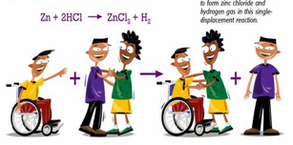
Date : _____________________________
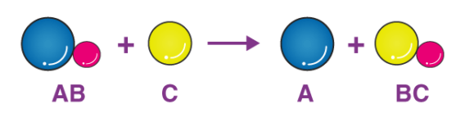
Single Displacement Reactions
In a single displacement reaction:

Ex. 1 – The single displacement reaction of zinc and copper ( II ) sulfate

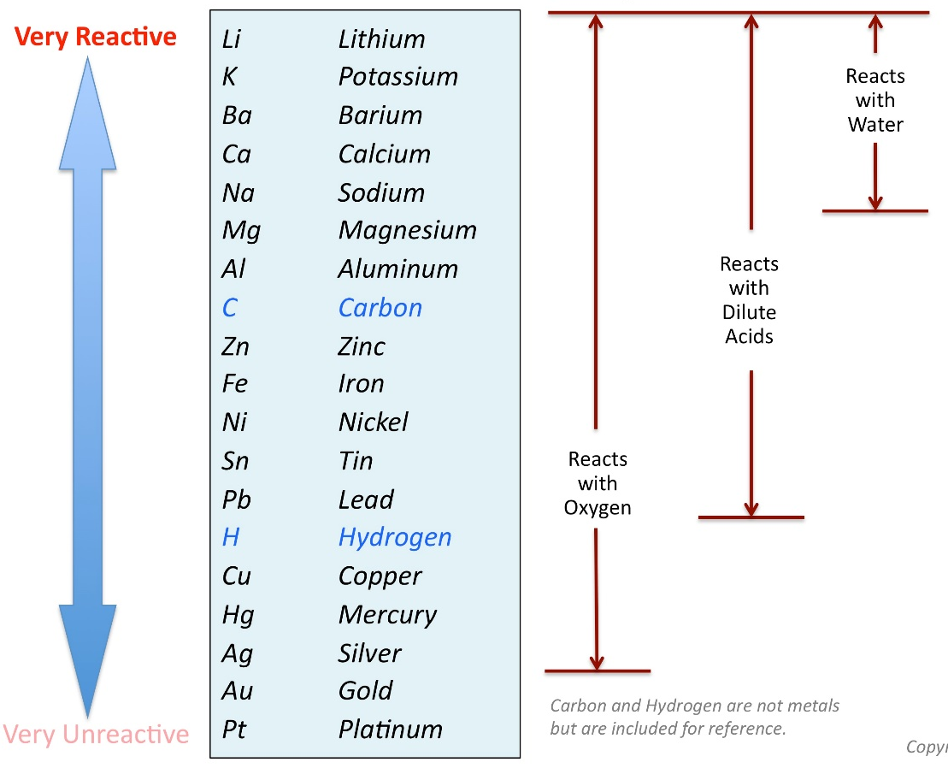
Do all metals replace each other? For example if you were wearing a gold ring and you spilled copper sulfate on your hands would it react? Any volunteers to test your hypothesis?

The Reactivity Series :
-A ranking of reactivity of metals
relative to each other.
-A metal higher in the list is able to displace a metal below it.
-The further apart the metal, the more likely the reaction will
occur.

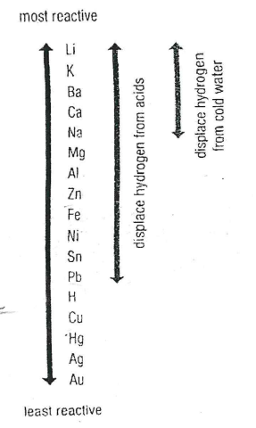
Predict if the following reactions will occur, if so write the balance chemical formula for the reaction
- Magnesium and copper ( II ) sulfate

- Lead and Zinc ( II ) nitrate

You try -

- Magnesium and silver nitrate


- Zinc and iron ( II ) chloride

- Nickle and aluminum nitrate

Reactions Involving Metal and Acid
Note – Treat acids like ionic compounds.
Ex. Lithium and sulfuric acid

Reactions Involving Water
Note – water can be written as __________, and treated like an ionic compound
Ex. Sodium and Water

You Try : Use the activity series to write a balanced chemical equation for each reaction that will occur.
- Calcium and hydrobromic acid (HBr) | - Copper and water
- Barium and water | - Mercury and sulfuric acid ( H₂SO₄ )

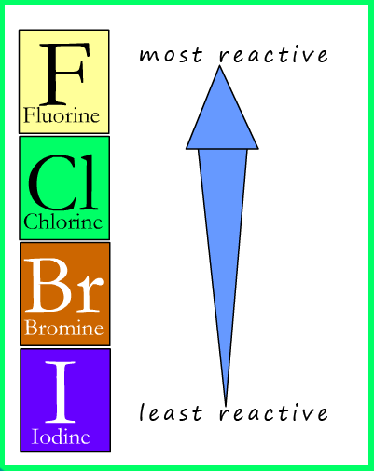
The Halogen Activity Series:
The halogen family also have their own activity series.
Note – In displacement reactions involving halogens the ________________________________ is being replace not the ______________________.

Ex. Write the balanced chemical equation for the reaction between chlorine and potassium iodide if you think the reaction will occur

