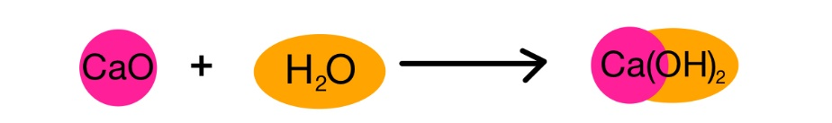
Date : ______________________________
Synthesis and Decomposition Reaction
In the previous unit you learned ( I hope ) that the periodic table is a useful tool to predict the properties of elements. Since the properties or an element are predictable, many of the chemical reactions they undergo are predictable as well.
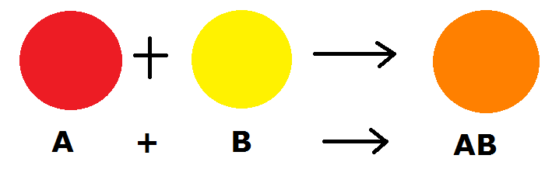
Synthesis Reactions :

Example 1 – Write the balanced chemical equations for the synthesis of magnesium and oxygen

Write the balanced chemical equation for the reaction of the following pairs of reactants:
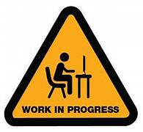
- Calcium and bromine

- Aluminum and oxygen

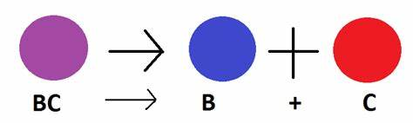
Decomposition Reactions :

Ex. 1 - Write the balanced chemical equation for the decomposition of potassium chloride

Ex. 2 - Write the balanced chemical equation for the decomposition of water

