Student full name: ___________________________
One mark deducted if you do not print your full name.

Learning Outcomes:
By the end of the activity the student must be able to:
Find the network interfaces active in a computer.
Capture traffic from a network connection.
Show the addresses that a computer uses while connected to the network.

Preparatory work:
- Download and install the most updated version of Wireshark from the Wireshark website.
Instructions:
- Do not erase anything from this document. On the contrary, insert all your answers into it following each step. Refer to the last page to know how to send your report. See “To submit” section.
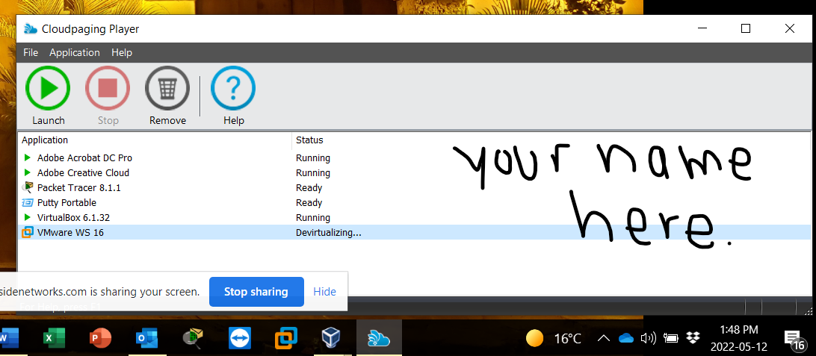
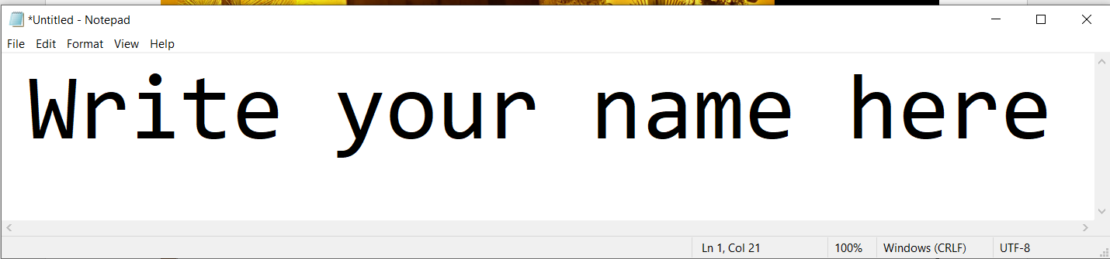
- How to insert screenshots in your report? Follow the example below. You must show the current date/time as it appears on your computer screen in the lower right corner. Print your name in any empty space of every screenshot taken. An example is below.

Procedure:

- Find the interfaces that Wireshark has automatically detected on your computer. Show the interface that shows the most frequent activity (not a flat line in front). You will have to use this interface to capture traffic.
Insert here the screenshot of the Wireshark Capture/Options as you have detected the interfaces of your computer. Resize the insert if necessary to make it easily readable. See the example below and replace it with your own screenshot. [one mark]
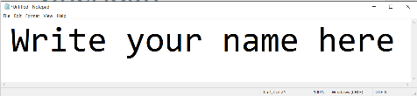
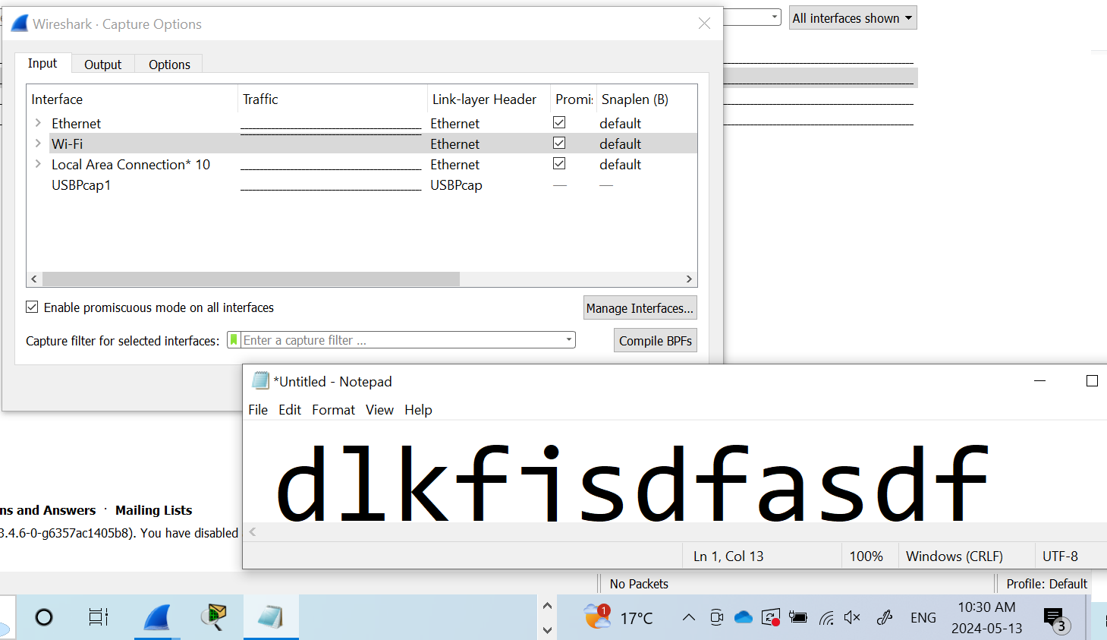

- Do click on the interface that connects your computer to the Internet and Wireshark starts capturing all packets sent to/from that interface. Browse a website (like slate.sheridancollege.ca) and be sure that you upload and/or download some information, like the slides corresponding to this week’s class. Wait for two minutes while your computer receives and/or sends some traffic. Stop the Capture process using the commands from the control bar. Use the Statistics/Capture file Properties option.
- Answer the following questions:
  - What was the average speed (bit/s) during the capture? [one mark] _________
  - How many packets were captured? [one mark] ______________________
  - How many bytes were captured? [one mark] ______________________
  - How long (minutes/seconds) was the capture? [one mark] _____________
  - Insert here the screenshot of the capture once you have stopped it. [one mark]

- Now you must figure out the identifiers (addresses) of the network interfaces you have on your computer. Use the Statistics/Endpoints option. Insert that screenshot here. [one mark]
- You can order the endpoints from the greatest to least number of packets. Answer the following questions:
  - Use the Ethernet tab. What is the physical address (or MAC address) of the interface with the largest number of packets? [one mark] ___________
    - Convert each hexadecimal character into four bits and write the binary code here. [one mark] _Example: 1010 1100 1110 1101 0101 1100 1101 0010 0000 1100 1100 0110___
    - How many bits is the MAC address? [one mark] _____________________
  - Now, go to the IPv4 tab. What is the IPv4 address of the interface with the largest number of packets? [one mark] _____________________
    - Convert each decimal number separated by dots into eight bits and write the binary code here. [one mark] _Example: 1010 1100 1110 1101 0101 1100 1101 0010 ______
    - How many bits long is the IPv4 address? [one mark] _____________________
  - Now, use the IPv6 tab. What is the IPv6 address of the interface with the largest number of packets? [one mark] _____________________
    - Take only the right part of IPv6 address shown after the fe80:: and convert each hexadecimal number into four bits. Write the binary code here. [one mark] _Example: 1010 1100 1110 1101 0101 1100 1101 0010 ________
    - How many bits long is the right part of the IPv6 address? [one mark] _____________________
  - Now, use the TCP tab. What is the TCP port number with the largest number of packets? [one mark] _____________________
    - Convert the TCP port number into binary code and write it here. [one mark] _Example: 1010 1100 1110 1101 0101 1100 1101 0010 ________
  - Finally, use the UDP tab. What is the UDP port with the largest number of packets? [one mark] _____________________
    - Convert the UDP port number into binary code and write it here. [one mark] _Example: 1010 1100 1110 1101 0101 1100 1101 0010 ________
    - How many bits long are the TCP or the UDP port numbers? [one mark] _____________________

- [One mark] Save the capture file on your computer using the default format given by the Wireshark software (PCAPNG). Keep the same file type but rename it using the following format: LASTNAME_FIRSTNAME_Activity1Capture. One mark deducted if you do not follow this format.

Instructions to send your report:

- Be sure that you print your full name on the first line of this report document. One mark deducted if you do not print your name at the beginning of this document.
- Save your report as a pdf file using the following format: LASTNAME_FIRSTNAME_Activity1.pdf. One mark deducted if you do not follow this format.
- Submit two files: One mark deducted if you do not send both files.
  - This report document in pdf format
  - The Wireshark capture file saved from question 6.
- Once you have finished the activity, send the files using the Slate drop box by the due date. Do not compress any files. One mark deducted if you compress a file.
- Revisit the Class Plan document to check for Late Submission penalties.

