IP Configuration in a LAN

Student Name: _________________ Student ID number ____________ / 10 marks

Instructions:
- Use this document to show all your work. Insert the calculations and figures as required. Do not modify its format. Do not compress it. Upload the file on Slate by the due date.
- Do not erase anything from this document. Keep all the same formatting. On the contrary, insert all your answers on it following each step. Refer to the last page to know how to submit your report.
- How to insert screenshots in your report? Follow the example below. You must show the current date/time as it appears on your computer screen in the lower right corner. Write down your name in any empty space of every screenshot taken. An example is shown below.

Scenario:
In this exercise, you will design IP addressing schemes for a company that wants to implement subnetworks in TWO countries (Canada and United States) for THREE departments each (Sales, Accounting, and Production).

Requirements:

Use Packet Tracer to correctly set network addresses on routers, switches, servers, and other end devices. Follow instructions given in class to correctly label and name each device. Go to the Options \ Preferences menu and be sure that you set it the way shown below.

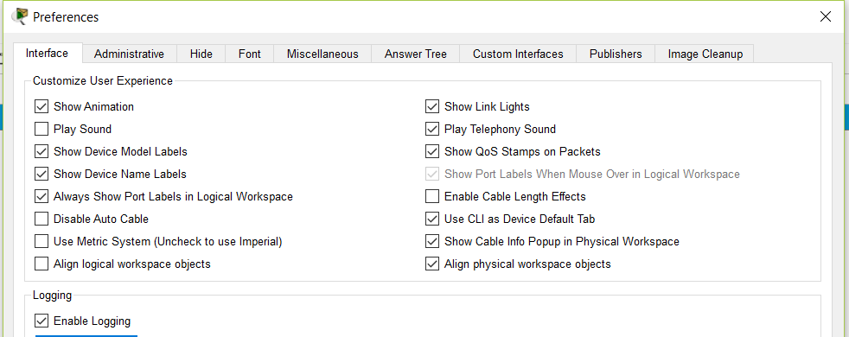

Network Topology

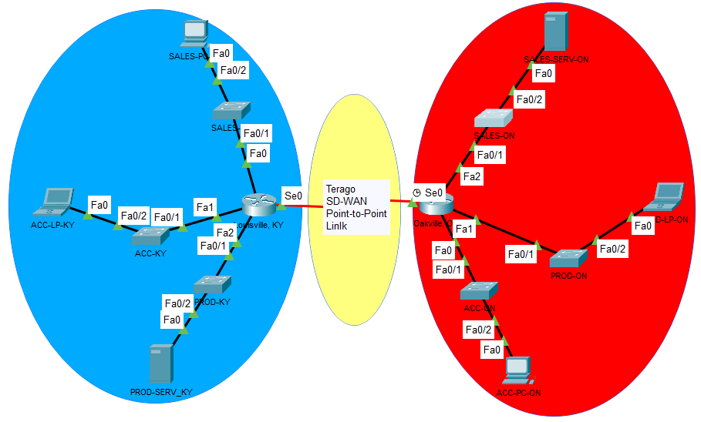
Fill the empty cells of the tables below. Do it according to the explanation provided in-class by the professor. Replace the XX characters by the last two digits of your student ID number.

Notice that the First usable address is calculated by adding 1 to the subnetwork address; the Last usable address is calculated by subtracting one to the Broadcast address; and the addresses for each subnetwork are assigned consecutively, it means that the next subnetwork address is calculated by adding one to the previous broadcast address.

[One mark] : Terago SD-WAN link. As a point-to-point link uses only two addresses, then the / number is /30.
Fill the following table with the addressing scheme.

Show at least one of the binaries to decimal calculations you made:
Example: 10.35.0.3 = 0000 1010 0000 0001 0000 0000 0000 0011 (32 bits) ________________________

Subnetwork | Addressable devices | Rounding up to 2^{n} | Subnetwork address | Mask  (/ number) | First usable  address | Last  Usable  address | Broadcast  address
WAN link | 2 (+2) | 4=2^2 | 10.35.XX.0 | 255.255.255.252  /30 | 10.35.XX.1 | 10.35.XX.2 | 10.35.XX.3

[Two marks]: Oakville, ON (Canada)
Fill the following table with the addressing scheme.

Show at least one of the binaries to decimal calculations you made:
____________________________________________________________________________________

Department | Addressable devices | Rounding up to 2^{n} | Subnetwork address (decimal dotted format) | Subnetwork Mask  (/ number) | First usable  Address (to be used on the GigabitEthernet ports of the router) | Last  Usable  address | Broadcast  address
Sales | 80 (+2) | 128=2^7 | 192.169.XX.0 | 255.255.255.128  /25 | 192.169.XX.1 |  | 192.169.XX.127
Accounting | 50 (+2) | 64=2^6 | 192.169.XX.128 | 255.255.255.192 /26 | 192.169.XX.129 |  | 192.169.XX.191
Production | 20 (+2) | 32=2^5 | 192.169.XX.192 | 255.255.255.224 /27 |  |  | 192.169.XX.223

Hints: 127 + 64 = 191 and 191 + 32 = 223 are the additions needed to find the broadcast address.

[Three marks]: Louisville – KY (USA)
Fill the following table with the addressing scheme.

Show here at least one of the binaries to decimal calculations you made:
________________________________________________________________________________________

Department | Addressable devices | Rounding up to 2^{n} | Subnetwork address | Mask  (/ number) | First usable  Address (to be used on the GigabitEthernet ports of the router) | Last  Usable  address | Broadcast  address
Sales | 60 (+2) | 64  H=6, N=26 | 192.169.<XX+10>.0 | 255.255.255.192 /26 |  |  | 192.169. <xx+10>.63
Accounting | 40 (+2) | 64 | 192.169. <XX+10>.64
Production | 30 (+2) | 32  H=5, N=27 | 192.169. <XX+10>.128

To submit:
Upload the following two files in the same submission:
- This file with all your answers. Name this file using the following format: FIRSTNAME_LASTNAME_ACTIVITY2.pdf. Do not compress the file. [one mark]
- The Packet Tracer file. Name this file using the following format: FIRSTNAME_LASTNAME_ACTIVITY2.pkt. Do not compress the file. [one mark]

Appendix: Example:

The following IP network address of a router Ethernet interface is given: 213.85.0.169 / 30

Let’s figure out the entire network it belongs to.

The address in dotted decimal notation: 213. 85. 0. 169
Converted to binary 32 bits: 11010101 01010101 00000000 10101001
Every address contains two parts: the network portion (N) and the host portion (H).
N + H = 32
Example 1: if N=30 obviously H=2
Example 2: if N=24, then H= 8. Consequently, we can create in this network 2^8 different addresses.
But, we cannot assign the first as well as the last. 2^8 – 2 =256 – 2 = 254 different addresses.
The / number is just the number of ones of the subnet mask.

Subnet mask (/ number): / 30 is equivalent to: thirty ones and two zeros.

32 bits: 11111111 11111111 11111111 11111100
Converted to decimal dotted notation: 255. 255. 255. 252

The 2 zero bits at the end mean: 2² = 4 possible combinations, but only the two in the middle are assignable to end user devices.

The first combination: 213.85.0. 168 corresponds to the network/subnetwork address.
The next two combinations are the available addresses will be:
213.85.0.169, and
213.85.0.170
The last combination: 213.85.0. 171 corresponds to the broadcast address.

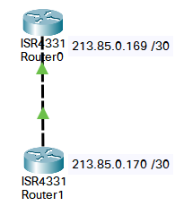

Some other useful conversions:
Powers of two | Possible values of last digit of Subnet Mask
512 = 2⁹  256 = 2⁸  128 = 2⁷  64 = 2⁶  32 = 2⁵  16 = 2⁴  8 = 2³  4 = 2²  2 = 2¹ | 255 = 1111 1111  254 = 1111 1110  252 = 1111 1100  248 = 1111 1000  240 = 1111 0000  224 = 1110 0000  192 = 1100 0000  128 = 1000 0000  0 = 0000 0000

