<Project Title> <- replace with an appropriate title for the project
Submitted by <Your Name> on <Date>

Description
COMPLETE THIS SECTION FIRST!!!
Replace this text with your proposal. It should be detailed and explain the purpose of the device. Provide examples of where your device could be used. Your device MUST have a practical purpose. Good examples are DICE THROWER, LCD Thermometer, or Remote Control Car. Must contain both inputs, outputs, and logic that work together to perform a function. Your device can be as complex as you like however it must be completed in the time allotted. Before continuing on I will review your proposal and provide feedback on moving forward.

Components Used
- <List all of the components used in your project, below are examples only and should be replaced with your components>
- 3x Light Emitting Diode (LED)--red
- 3x 220 ohm resistor
- 10k resistor
- 1M resistor
- Arduino board
- Bread board
- Wires
- Photocell
- Piezo speaker
- Flashlight
- Candle holder
- Electrical tape

Arduino Code
<Paste your control code here. Use Roboto Mono font 9pt. Do NOT forget to comment your code!>
/* Piezo candle
* A photocell activates an LED when enough light is provided (by a "match").
* A piezo registers the vibration of a forceful blow to turn the LED off.
*/

const int ledPin = 13; // led connected to digital pin 13
const int blowSensor = 0; // the Piezo is connected to analog pin 0
const int threshold = 5; // threshold value to decide when vibration is detected
const int lightSensor = 2; // the photocell is connected to analog pin 2

int sensorReading = 0; // variable to store the value read from the sensor pin
int val = 0; //variable to store the value coming from the photocell

void setup() {
pinMode(ledPin, OUTPUT); // declare the ledPin as as OUTPUT
}
void loop() {
// read the sensor and store it in the variable sensorReading:
val = analogRead(lightSensor); //read the value from the photocell
if (val > 400) {
// update the LED to be on
digitalWrite(ledPin, HIGH);
}
sensorReading = analogRead(blowSensor);
// if the sensor reading is greater than the threshold:
if (sensorReading >= threshold) {
// update the LED pin to be off
digitalWrite(ledPin, LOW);
}
delay(100); // delay
}

Photos (or Video)
<Paste at least 1 photo of your completed project here. You may also post a video and/or multiple photos illustrating the construction.>
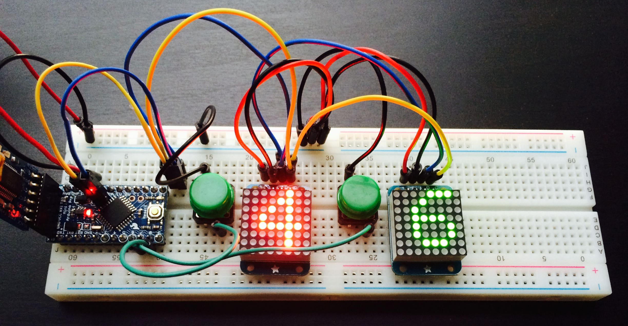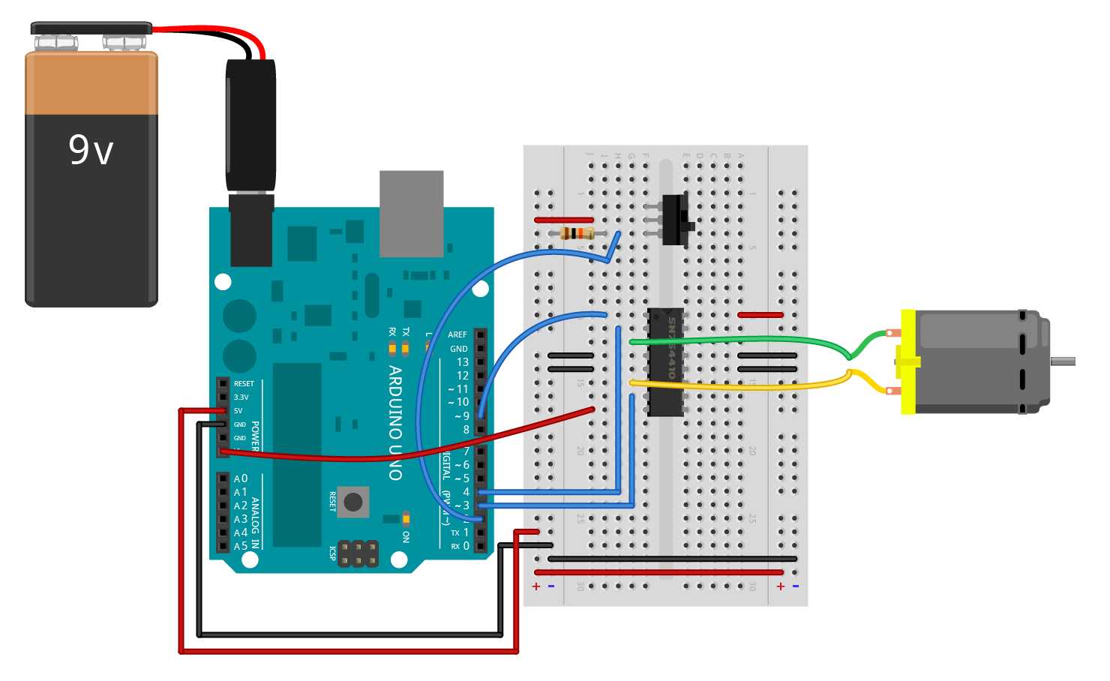

Schematic
<Paste in the Schematic created by TinkerCAD using Schematic VIEW.>

