Time online vs sleeping
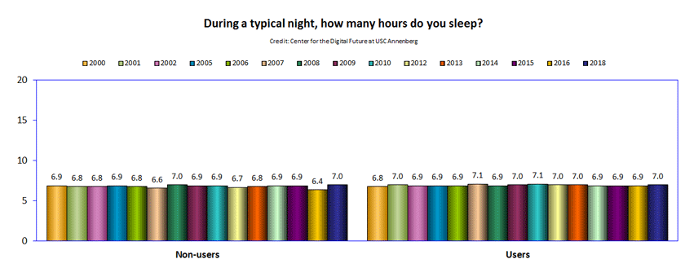
Summary:
The internet doesnt inherently degrade sleep,but the more time spent online has a negative correlation to time sleeping

Sources:
https://www.digitalcenter.org/web-insights/hours-sleep/ [1]
https://www.reddit.com/r/ask/comments/1h0h9sd/how_many_hours_is_everyone_online_and_how_much/ [2]

